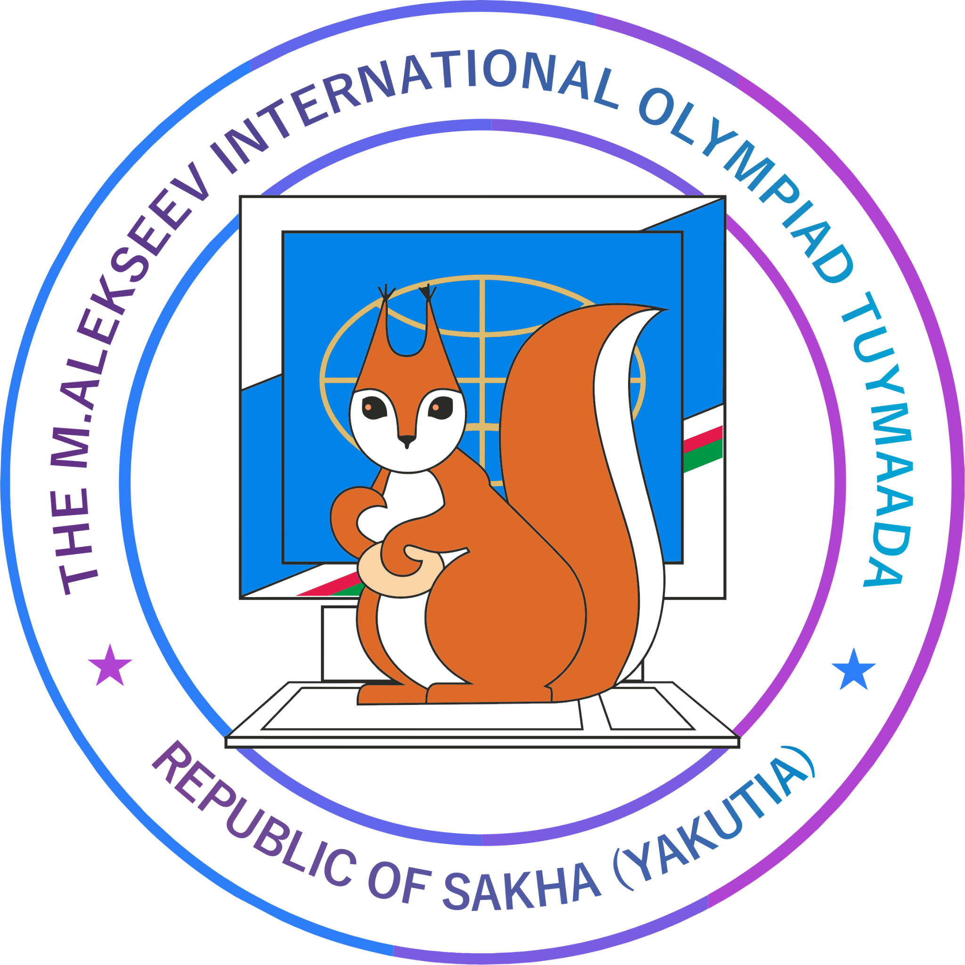

**P R O G R A M M E**

of the M. Alekseev XXXII International Olympiad "Tuymaada"

in mathematics, physics, chemistry and informatics

***(for online participants)***

**Dates of the event:** July 2 - 10, 2025

| **Moscow**  **(GMT +3)** | **Event** | **Location** |
| --- | --- | --- |
| **July 2, Wednesday** | | |
| 02:00-03:00 PM | **Presentation of the teams via video connection.** | Connect to the conference Zoom:  <https://us06web.zoom.us/j/87474674884?pwd=RKiq6JbsNqWrCuOaaaN9ZdhhTTSWcS.1>  Identifier: 874 7467 4884  Code: 622578 |
| **July 3, Thursday** | | |
| 10:00 AM  -11:00 AM | **The grand opening of the M.Alekseev XXXII International Olympiad "Tuymaada" in mathematics, physics, chemistry and informatics** | Connect to the conference Zoom:  <https://us06web.zoom.us/j/84688881793?pwd=i2RJpFAznfhMgOi17mJBEuzgDF1h0N.1>  Identifier: 846 8888 1793  Code: 328452 |
| 11:15 AM | **Orientation workshop on Technical Regulations for online participants on Mathematics, Chemistry.** | Connect to the conference Zoom:  <https://us06web.zoom.us/j/83577274827?pwd=C6ON6Qb1RX3KXK4x8mbQVeJKjZHQ4x.1>  Identifier: 835 7727 4827  Code: 348469 |
| 2:15 PM - 3:00 PM | **System testing, site verification for online participants on Mathematics, Chemistry. Trial tour on Informatics** | Preparation of webcams, headphones.  *Logins and passwords have been sent to team leaders.*  Connect to the conference Zoom: |
| **July 4, Friday** | | |
| 09:00 AM  -02:00 PM | **Olympiad: the first day (first rounds)** | video surveillance system proctoring |
| **July 5, Saturday** | | |
| 09:00 AM  -02:00 PM | **Olympiad: the second day (second rounds)** | video surveillance system proctoring |
| **July 6, Sunday** | | |
| 11:00 AM  -01:00 PM | **The methodological seminar in an Ed Crunch format *(for team leaders)*** | Connect to the conference Zoom:  <https://us06web.zoom.us/j/86010698278?pwd=kBad4DZ13YrUa07ljzzU5FDE5tFMuF.1> |
| 01:00 PM | **Preliminary results of the Olympiad and the beginning of accepting applications for appeal in CHEMISTRY** | Preliminary results are published on the Olympiad website <http://tuymaada.lensky-kray.ru/en/>  Acceptance of applications via the organizers' e-mail |
| 03:00 PM - 04:30 PM | **Cultural evening (with the participants of Science Fair)** | Connect to the conference Zoom: |
| **July 7, Monday** | | |
| 02:00 PM | **Appeal for participants of the Olympiad on CHEMISTRY** | Connect to the conference Zoom:  *(links will come later)* |
| **July 8, Tuesday** | | |
| 09:00 AM - 12:00 PM | **Preliminary results of the Olympiad and the beginning of accepting applications for appeal in MATHEMATICS, INFORMATICS** | Preliminary results are published on the Olympiad website <http://tuymaada.lensky-kray.ru/en/>  Acceptance of applications via the organizers' e-mail |
| 03:00 PM | **Appeal for participants of the Olympiad on MATHEMATICS, INFORMATICS** | Connect to the conference Zoom:  *(links will come later)* |
| **July 9, Wednesday** | | |
|  |  |  |
| **July 10, Thursday** | | |
| 11:00 AM | **Closing ceremony of the M. Alekseev XXXII International Olympiad "Tuymaada" in mathematics, physics, chemistry and informatics** | Connect to the conference Zoom: |